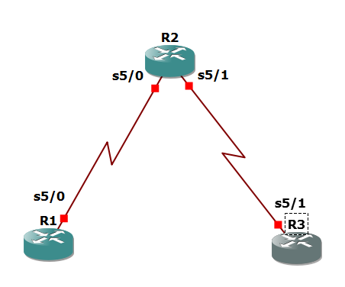

R1

conf t

hostname R1

interface Loopback 0

description R1 LAN

ip address 192.168.1.1 255.255.255.0

exit

!

interface Serial5/0

description R1 --> R2

ip address 10.1.1.1 255.255.255.252

clock rate 128000

no shutdown

exit

!

end

R2

conf t

hostname R2

!

interface Serial5/0

description R2 --> R1

ip address 10.1.1.2 255.255.255.252

no shutdown

exit

interface Serial5/1

description R2 --> R3

ip address 10.2.2.1 255.255.255.252

clock rate 128000

no shutdown

exit

!

end

R3

conf t

hostname R3

!

interface Loopback0

description R3 LAN

ip address 192.168.3.1 255.255.255.0

exit

interface Serial5/1

description R3 --> R2

ip address 10.2.2.2 255.255.255.252

no shutdown

exit

!

end

R1(config)# ip route 0.0.0.0 0.0.0.0 10.1.1.2

R3(config)# ip route 0.0.0.0 0.0.0.0 10.2.2.1

R2(config)# ip route 192.168.1.0 255.255.255.0 10.1.1.1

R2(config)# ip route 192.168.3.0 255.255.255.0 10.2.2.2

R1# tclsh

foreach address {

192.168.1.1

10.1.1.1

10.1.1.2

10.2.2.1

10.2.2.2

192.168.3.1

} { ping $address }

R1(config)# security passwords min-length 10

R1(config)# enable secret class12345

R1(config)# line console 0

password ciscoconpass

exec-timeout 5 0

login

logging synchronous

exit

R1(config)# line vty 0 4

password ciscovtypass

exec-timeout 5 0

login

exit

R1(config)# line aux 0

no exec

end

R1(config)# service password-encryption

R1(config)# banner motd $Unauthorized access strictly prohibited!$

R1(config)# exit

R3(config)# security passwords min-length 10

R3(config)# enable secret class12345

R3(config)# line console 0

password ciscoconpass

exec-timeout 5 0

login

logging synchronous

exit

R3(config)# line vty 0 4

password ciscovtypass

exec-timeout 5 0

login

exit

R3(config)# line aux 0

no exec

end

R3(config)# service password-encryption

R3(config)# banner motd $Unauthorized access strictly prohibited!$

R3(config)# exit

R1(config)# username JR-ADMIN secret class12345

R1(config)# username ADMIN secret class54321

R1(config)# line console 0

login local

exit

R1(config)# line vty 0 4

login local

end

R3(config)# username JR-ADMIN secret class12345

R3(config)# username ADMIN secret class54321

R3(config)# line console 0

login local

exit

R3(config)# line vty 0 4

login local

end

R1# telnet 10.2.2.2

Username: ADMIN

Password: class54321

R3>

R1(config)# aaa new-model

R1(config)# radius server RADIUS-1

address ipv4 192.168.1.101

key RADIUS-1-pa55w0rd

exit

R1(config)# radius server RADIUS-2

address ipv4 192.168.1.102

key RADIUS-2-pa55w0rd

exit

R1(config)# aaa group server radius RADIUS-GROUP

server name RADIUS-1

server name RADIUS-2

exit

R1(config)# aaa authentication login default group RADIUS-GROUP local

R1(config)# aaa authentication login TELNET-LOGIN group RADIUS-GROUP local-case

R1(config)# line vty 0 4

login authentication TELNET-LOGIN

exit

R3(config)# aaa new-model

R3(config)# radius server RADIUS-1

address ipv4 192.168.1.101

key RADIUS-1-pa55w0rd

exit

R3(config)# radius server RADIUS-2

address ipv4 192.168.1.102

key RADIUS-2-pa55w0rd

exit

R3(config)# aaa group server radius RADIUS-GROUP

server name RADIUS-1

server name RADIUS-2

exit

R3(config)# aaa authentication login default group RADIUS-GROUP local

R3(config)# aaa authentication login TELNET-LOGIN group RADIUS-GROUP local-case

R3(config)# line vty 0 4

login authentication TELNET-LOGIN

exit

R1# telnet 10.2.2.2

Username: admin

Password: class12345

Username: ADMIN

Password: class54321

R3>

R1(config)# ip domain-name ccnasecurity.com

R1(config)# crypto key zeroize rsa

R1(config)# crypto key generate rsa general-keys modulus 1024

R1(config)# ip ssh version 2

R1(config)# line vty 0 4

transport input ssh

end

R1# show ip ssh

R3(config)# ip domain-name ccnasecurity.com

R3(config)# crypto key zeroize rsa

R3(config)# crypto key generate rsa general-keys modulus 1024

R3(config)# ip ssh version 2

R3(config)# line vty 0 4

transport input ssh

end

R3# show ip ssh

R1# ssh -l ADMIN 10.2.2.2

Password:class54321

R3> en

Password:class12345

R3#